**PRATICAL NO.1**

1. **Write a MongoDB query to create and drop database.**

Create DB :

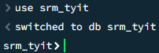

Drop DB :

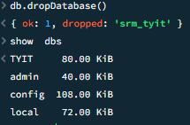

1. **Write a MongoDB query to create, display and drop collection**

Create collection :

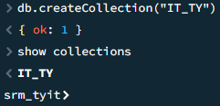

Display collections :



Drop collection :

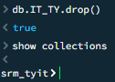

1. **Write a MongoDB query to insert, query, update and delete a document.**

Insert document :

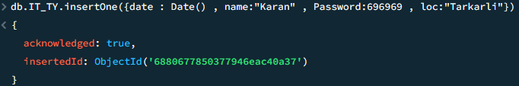

Query of document :

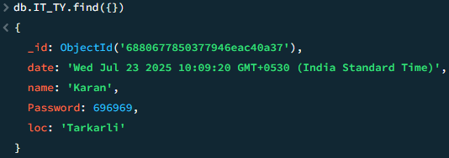

Update document :

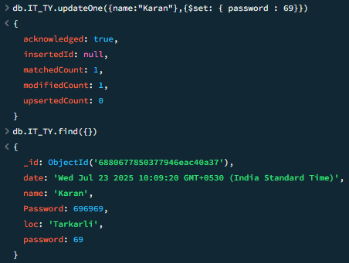

Delete a document :

